HTML APIs

📘 Definition
# Source: AI Source: Provided by: [Data Path: Persons Table -> ID Column: 1, Name_En Column: Motasem Essam] -> From: [ChatGPT] on [5/6/2026]
HTML APIs (Application Programming Interfaces) allow JavaScript to interact with browser features and webpage elements.
APIs help developers:
- access browser functions
- store data
- draw graphics
- play media
- get user location
- create web applications

🧠 Common HTML APIs
# Source: AI Source: Provided by: [Data Path: Persons Table -> ID Column: 1, Name_En Column: Motasem Essam] -> From: [ChatGPT] on [5/6/2026]
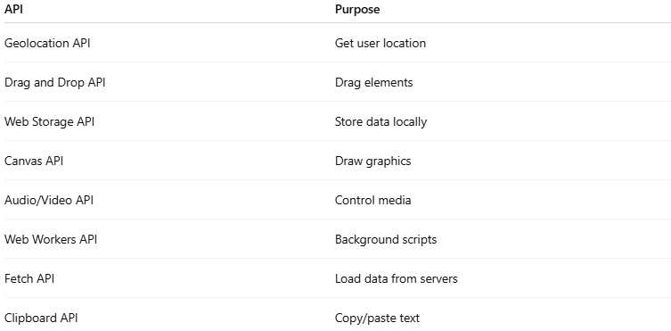
API | Purpose
Geolocation API | Get user location
Drag and Drop API | Drag elements
Web Storage API | Store data locally
Canvas API | Draw graphics
Audio/Video API | Control media
Web Workers API | Background scripts
Fetch API | Load data from servers
Clipboard API | Copy/paste text

1. 📍 Geolocation API
# Source: AI Source: Provided by: [Data Path: Persons Table -> ID Column: 1, Name_En Column: Motasem Essam] -> From: [ChatGPT] on [5/6/2026]
📖 Description
Gets the user's geographic location.
💻 Example:
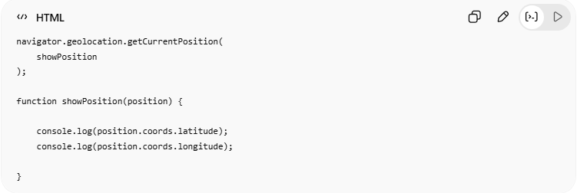
navigator.geolocation.getCurrentPosition(
showPosition
);
function showPosition(position) {
console.log(position.coords.latitude);
console.log(position.coords.longitude);
}

2. 🖱️ Drag and Drop API
# Source: AI Source: Provided by: [Data Path: Persons Table -> ID Column: 1, Name_En Column: Motasem Essam] -> From: [ChatGPT] on [5/6/2026]
📖 Description
Allows dragging and dropping elements.
💻 Example:
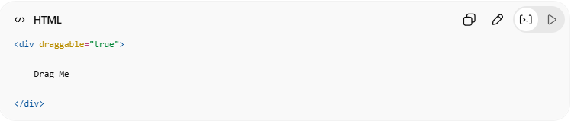
<div draggable="true">
Drag Me
</div>

3. 💾 Web Storage API
# Source: AI Source: Provided by: [Data Path: Persons Table -> ID Column: 1, Name_En Column: Motasem Essam] -> From: [ChatGPT] on [5/6/2026]
📖 Description
Stores data in the browser.
🧩 Storage Types
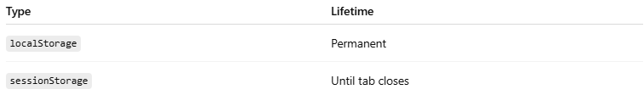
Type | Lifetime
localStorage | Permanent
sessionStorage | Until tab closes
💻 Example:
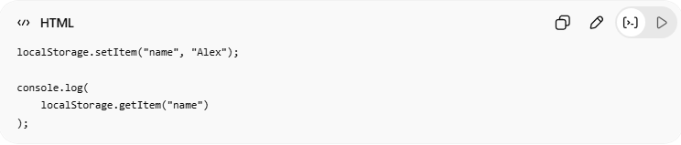
localStorage.setItem("name", "Alex");
console.log(
localStorage.getItem("name")
);

4. 🎨 Canvas API
# Source: AI Source: Provided by: [Data Path: Persons Table -> ID Column: 1, Name_En Column: Motasem Essam] -> From: [ChatGPT] on [5/6/2026]
📖 Description
Draws graphics with JavaScript.
💻 Example:
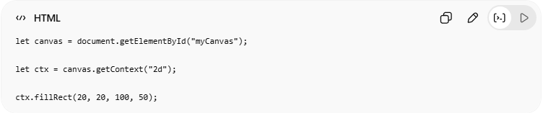
let canvas = document.getElementById("myCanvas");
let ctx = canvas.getContext("2d");
ctx.fillRect(20, 20, 100, 50);

5. 🎵 Audio/Video API
# Source: AI Source: Provided by: [Data Path: Persons Table -> ID Column: 1, Name_En Column: Motasem Essam] -> From: [ChatGPT] on [5/6/2026]
📖 Description
Controls media playback.
💻 Example:
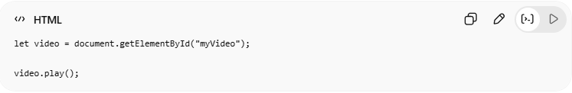
let video = document.getElementById("myVideo");
video.play();

6. ⚙️ Web Workers API
# Source: AI Source: Provided by: [Data Path: Persons Table -> ID Column: 1, Name_En Column: Motasem Essam] -> From: [ChatGPT] on [5/6/2026]
📖 Description
Runs JavaScript in the background.
💻 Example:
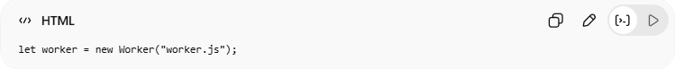
let worker = new Worker("worker.js");
👉 Prevents UI freezing

7. 🌐 Fetch API
# Source: AI Source: Provided by: [Data Path: Persons Table -> ID Column: 1, Name_En Column: Motasem Essam] -> From: [ChatGPT] on [5/6/2026]
📖 Description
Loads data from servers/APIs.
💻 Example:
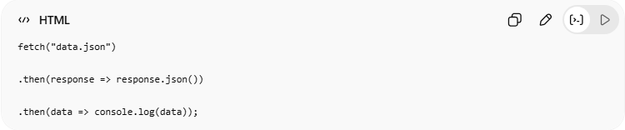
fetch("data.json")
.then(response => response.json())
.then(data => console.log(data));

8. 📋 Clipboard API
# Source: AI Source: Provided by: [Data Path: Persons Table -> ID Column: 1, Name_En Column: Motasem Essam] -> From: [ChatGPT] on [5/6/2026]
📖 Description
Copies text to clipboard.
💻 Example:
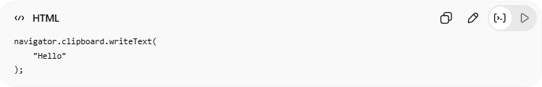
navigator.clipboard.writeText(
"Hello"
);

💻 Example

Full Example
# Source: AI Source: Provided by: [Data Path: Persons Table -> ID Column: 1, Name_En Column: Motasem Essam] -> From: [ChatGPT] on [5/6/2026]
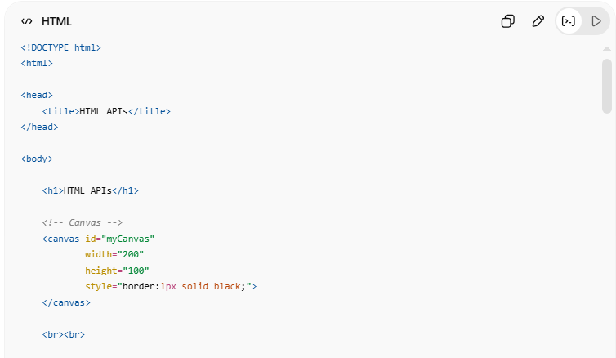
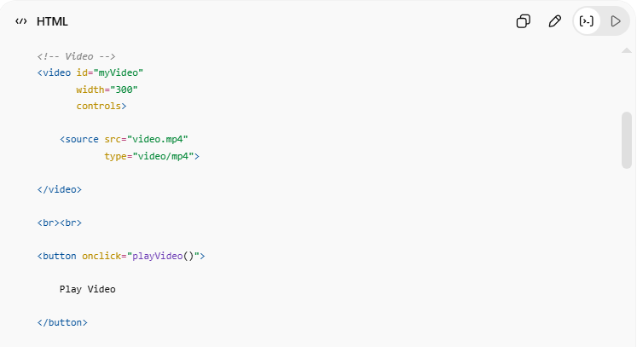
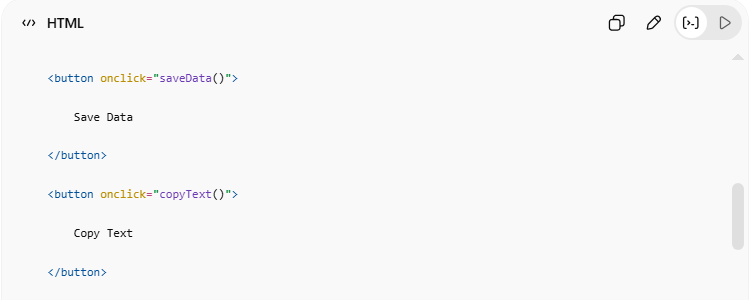
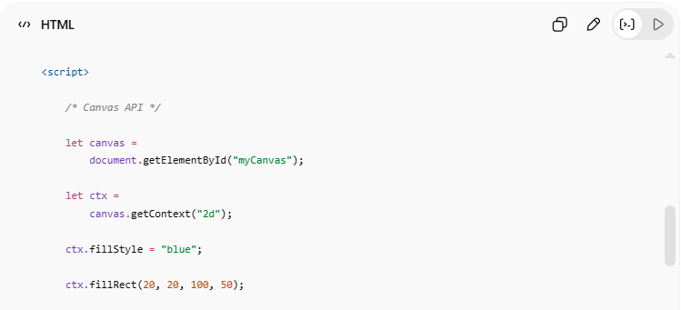
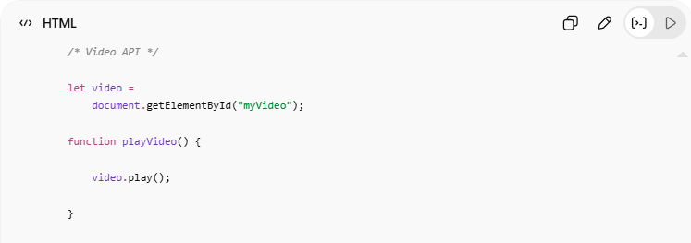
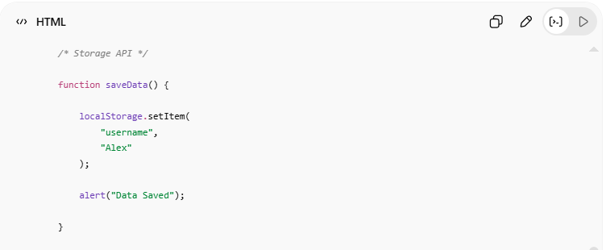
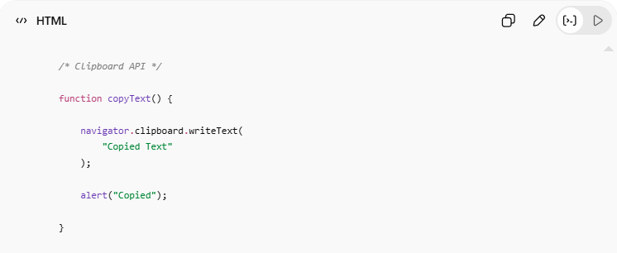
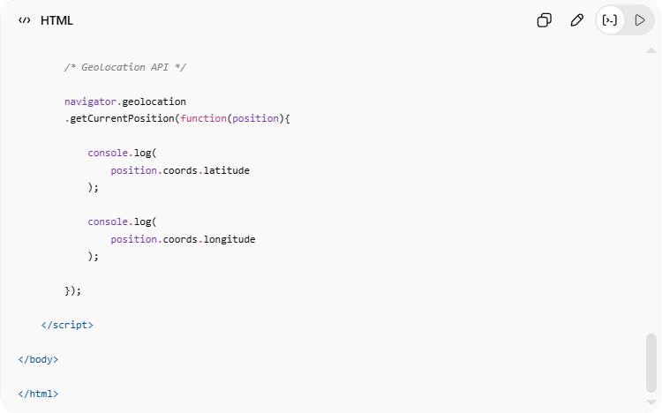
<!DOCTYPE html>
<html>
<head>
<title>HTML APIs</title>
</head>
<body>
<h1>HTML APIs</h1>
<!-- Canvas -->
<canvas id="myCanvas"
width="200"
height="100"
style="border:1px solid black;">
</canvas>
<br><br>
<!-- Video -->
<video id="myVideo"
width="300"
controls>
<source src="video.mp4"
type="video/mp4">
</video>
<br><br>
<button onclick="playVideo()">
Play Video
</button>
<button onclick="saveData()">
Save Data
</button>
<button onclick="copyText()">
Copy Text
</button>
<script>
/* Canvas API */
let canvas =
document.getElementById("myCanvas");
let ctx =
canvas.getContext("2d");
ctx.fillStyle = "blue";
ctx.fillRect(20, 20, 100, 50);
/* Video API */
let video =
document.getElementById("myVideo");
function playVideo() {
video.play();
}
/* Storage API */
function saveData() {
localStorage.setItem(
"username",
"Alex"
);
alert("Data Saved");
}
/* Clipboard API */
function copyText() {
navigator.clipboard.writeText(
"Copied Text"
);
alert("Copied");
}
/* Geolocation API */
navigator.geolocation
.getCurrentPosition(function(position){
console.log(
position.coords.latitude
);
console.log(
position.coords.longitude
);
});
</script>
</body>
</html>

Real Example
# Source: ScreenShot Source: Provided by: [Persons Table -> ID Column: 1, Name_En Column: Motasem Essam] -> Tool: [Automation Table -> ID Column: 16, Name_En Column: Screen Capture] -> From [Operating System: Windows] on [5/6/2026]
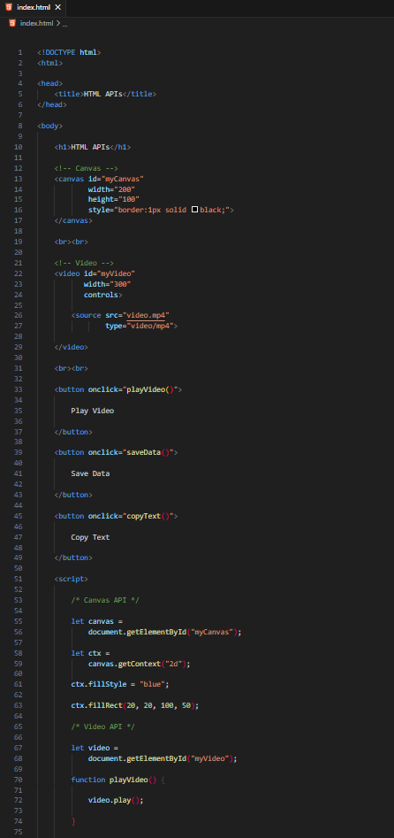

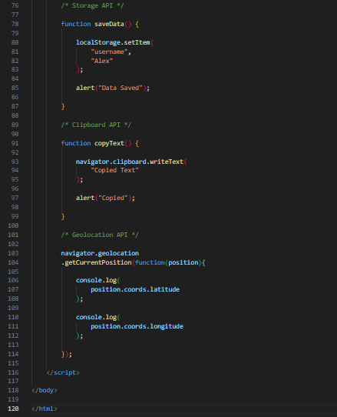
<!DOCTYPE html>
<html>

<head>
<title>HTML APIs</title>
</head>

<body>

<h1>HTML APIs</h1>

<!-- Canvas -->
<canvas id="myCanvas"
width="200"
height="100"
style="border:1px solid black;">
</canvas>

<br><br>

<!-- Video -->
<video id="myVideo"
width="300"
controls>

<source src="video.mp4"
type="video/mp4">

</video>

<br><br>

<button onclick="playVideo()">

Play Video

</button>

<button onclick="saveData()">

Save Data

</button>

<button onclick="copyText()">

Copy Text

</button>

<script>

/* Canvas API */

let canvas =
document.getElementById("myCanvas");

let ctx =
canvas.getContext("2d");

ctx.fillStyle = "blue";

ctx.fillRect(20, 20, 100, 50);

/* Video API */

let video =
document.getElementById("myVideo");

function playVideo() {

video.play();

}

/* Storage API */

function saveData() {

localStorage.setItem(
"username",
"Alex"
);

alert("Data Saved");

}

/* Clipboard API */

function copyText() {

navigator.clipboard.writeText(
"Copied Text"
);

alert("Copied");

}

/* Geolocation API */

navigator.geolocation
.getCurrentPosition(function(position){

console.log(
position.coords.latitude
);

console.log(
position.coords.longitude
);

});

</script>

</body>

</html>
# Source: GIF Source: Provided by: [Persons Table -> ID Column: 1, Name_En Column: Motasem Essam] -> Tool: [Automation Table -> ID Column: 17, Name_En Column: GIF Recorder] -> From [Operating System: Windows] on [5/6/2026]
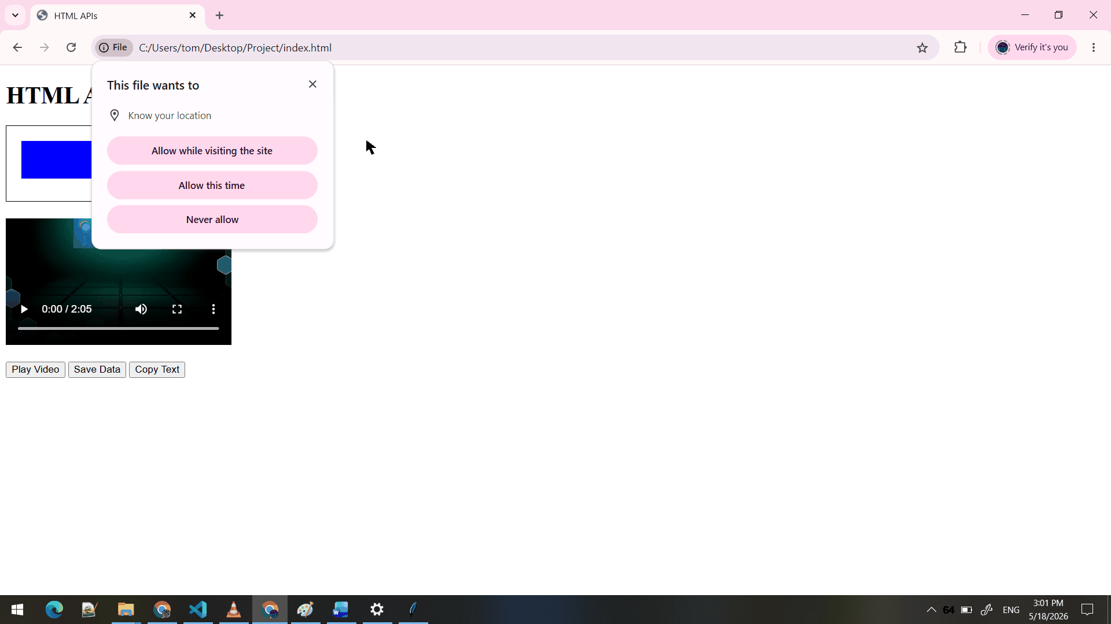

🧪 What You Can Test
# Source: AI Source: Provided by: [Data Path: Persons Table -> ID Column: 1, Name_En Column: Motasem Essam] -> From: [ChatGPT] on [5/6/2026]
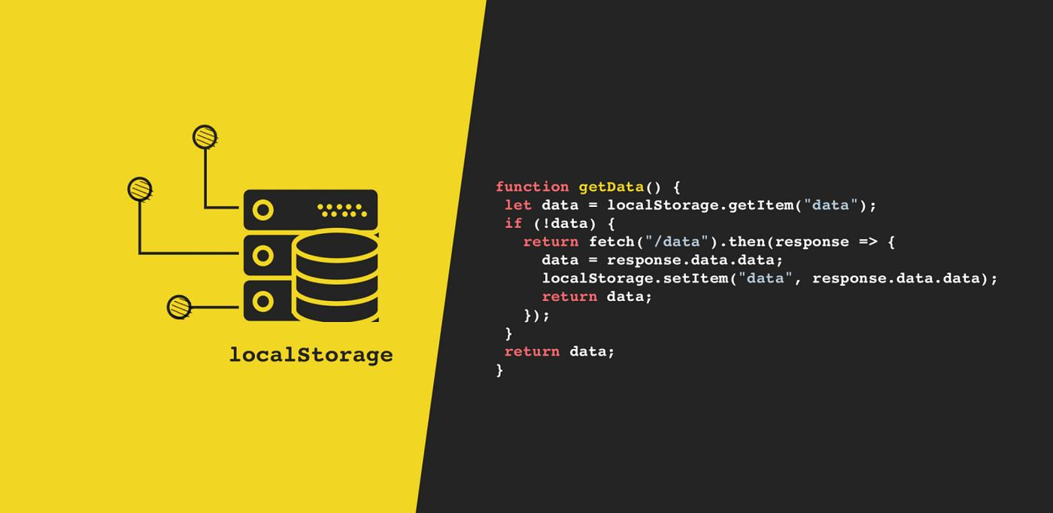
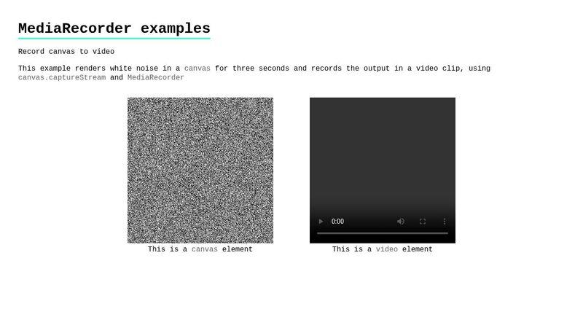
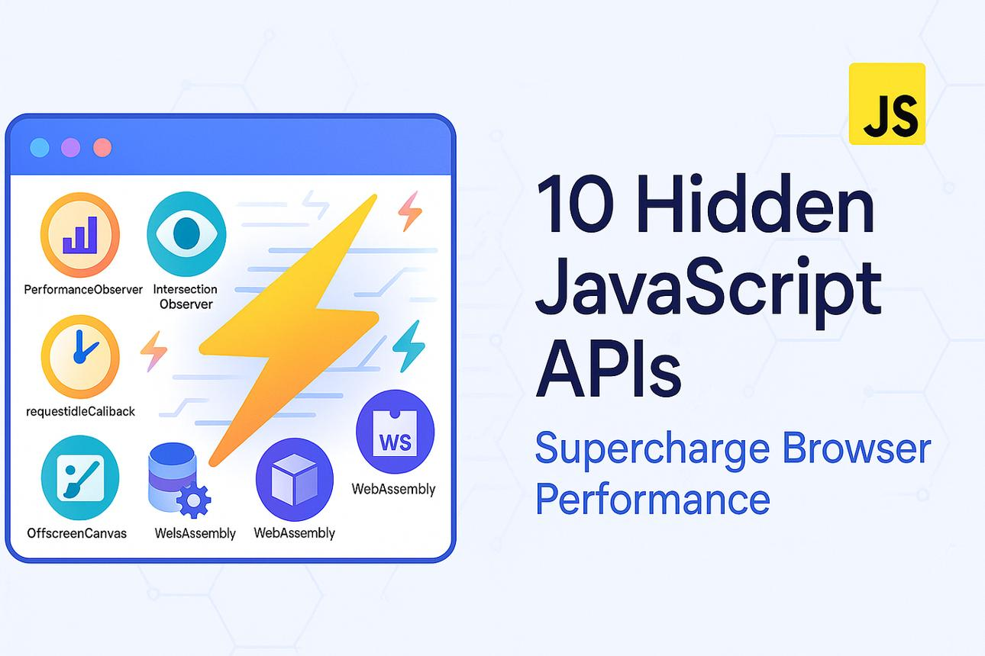
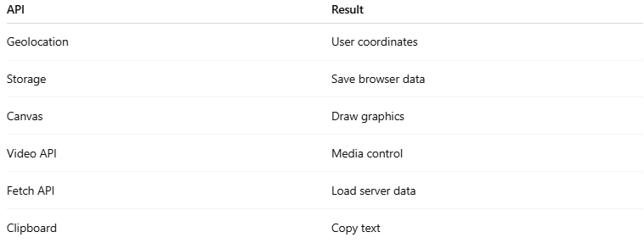
API | Result
Geolocation | User coordinates
Storage | Save browser data
Canvas | Draw graphics
Video API | Media control
Fetch API | Load server data
Clipboard | Copy text

⚠️ Important Notes

✅ Many APIs require JavaScript
# Source: AI Source: Provided by: [Data Path: Persons Table -> ID Column: 1, Name_En Column: Motasem Essam] -> From: [ChatGPT] on [5/6/2026]
👉 HTML alone is not enough

✅ Some APIs need user permission
# Source: AI Source: Provided by: [Data Path: Persons Table -> ID Column: 1, Name_En Column: Motasem Essam] -> From: [ChatGPT] on [5/6/2026]
👉 Example:
- geolocation
- clipboard
- camera
- microphone

✅ APIs may behave differently across browsers
# Source: AI Source: Provided by: [Data Path: Persons Table -> ID Column: 1, Name_En Column: Motasem Essam] -> From: [ChatGPT] on [5/6/2026]
👉 Always test compatibility

❌ Avoid storing sensitive data in localStorage
# Source: AI Source: Provided by: [Data Path: Persons Table -> ID Column: 1, Name_En Column: Motasem Essam] -> From: [ChatGPT] on [5/6/2026]
👉 Not secure for passwords

🚀 In short:
# Source: AI Source: Provided by: [Data Path: Persons Table -> ID Column: 1, Name_En Column: Motasem Essam] -> From: [ChatGPT] on [5/6/2026]
HTML APIs allow JavaScript to access browser features like storage, graphics, media, geolocation, networking, clipboard, and background processing.

